CHILD SAFEGUARDING REPORTING PROCEDURE
ELC AND SAC SERVICES
If you have a safeguarding concern in this organisation, you must follow our Child Safeguarding Reporting Procedure by contacting the Designated Liaison Person.
Insert Name here
Insert Name here
Insert Name here
Designated Liaison Person:

Contact Details:
Deputy Designated Liaison Person:

Contact Details:
TULSA Dedicated Contact Point:

Phone Number:
Insert details here
Insert details here
Insert details here
If applicable, our Child Safeguarding Statement is available and displayed prominently

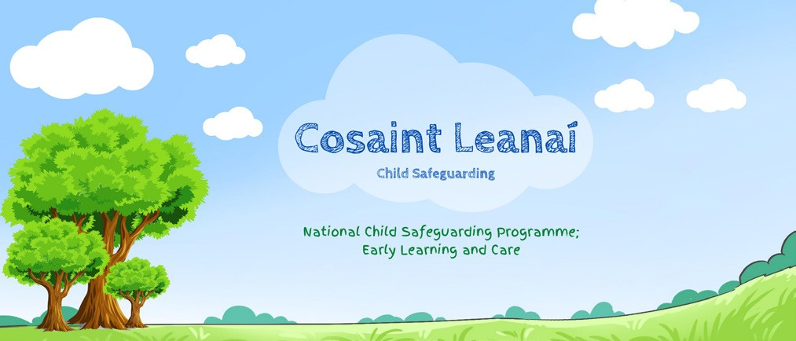
We have the following procedures in place:
- Procedure for the management of allegations of abuse or misconduct against workers/volunteers of a child availing of our service
•
•
Procedure for the safe recruitment and selection of workers and volunteers to work with children
Procedure for provision of and access to child safeguarding training and information, including the identification of the occurrence of harm
•
•
•
•
Procedure for the reporting of child protection or welfare concerns to Tusla
Procedure for maintaining a list of the persons (if any) in the relevant service who are mandated persons
Procedure for appointing a Relevant Person

All Other Procedures to Mitigate Risks Outlined in our Risk Assessment

